May Outline


Feel free to browse the website to get a sneak peak & start your wish list: SHOWURL
______ is hosting a LIVE Virtual Pampered Chef party on DATE/TIME.
What is that!??
Just JOIN this event, and then meet us back here on DATE/TIME. The Pampered Chef consultant will be LIVE posting recipes, doing a couple giveaways, sharing some amazing Pampered Chef products and videos, and there will be games!! You won't want to miss this exciting NEW Pampered Chef experience. Live event will last just 1 hour.
Get your Pampered Chef fix from the comfort of your own home. Get comfy, grab your favorite drink and meet us back here for the LIVE event!
There will be an ON TIME drawing. Don't be late! :)

** SEND TO HOST- DO NOT POST IN EVENT** They will find all of the information they will need to have a VERY successful party!
___________________________________
Hi! I just wanted to give you some great tips to make your party as successful as possible so that you can get the most FREE product! Please click on this link to get some great tips for your party:pcvirtualparty.weebly.com

AFTER YOU SET UP EVENT:
______________________
I am so excited about HOST's virtual Pampered Chef party! This is a fun, fast paced and exciting LIVE event that will last about an hour.
I will post some of our amazing products, some recipes, games, and giveaways, and you'll be able to place an order at the end to support your host, if you see anything you like!
Feel free to browse ahead of time and place an order, or, you can wait until the live event to order.
Browsing/ordering through this link: URL

DAY YOU SET UP EVENT: (Feel free to use this image I have created, or create your own with your own categories)
__________________________
Who loves a GIVEAWAY!? At the end of the party, somebody will win a prize! You can earn entries into the drawing by participating through this party. Please help makes this event lots of FUN by commenting and joining in on all the posts!

Pre-Party Post:
_______________________
While we wait for the party- how about sharing your favorite Pampered Chef product? Here is one of mine! Our Simple Slicer ($32.00) is perfect for quick meal prep. Plus, it has a safety to protect the user from the blade. Tell us your favorites, you'll get a bonus entry into the drawing at the end of the party for telling us WHY you love it!
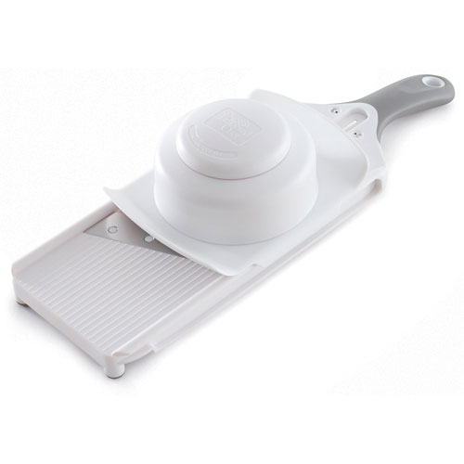
Comments:
The perfect slice of onion (or tomato, potato, zucchini, etc) every time!
Simple Slicer Item #1099- $32.00
Slicing has never been easier than it is with the Simple Slicer! Just slide the food holder onto the track, pop in fruit or veggies and slide back and forth for perfect slices. Use this handheld slicer over a bowl or cutting board—the nonskid feet will keep it in place!
Details
Blade adjusts to 1/16”, 1/8” and 3/16” thicknesses.
Safety lock raises the body so the blade isn’t exposed when stored.
Nonskid feet.
Dishwasher-safe
Pre Show
Any wine lovers!? This is another one of my favorites! Opens a wine bottle in SECONDS!
Wine Bottle Opener #2199 $37.50
Carbon steel corkscrew with nonstick coating spirals through natural and synthetic corks. Single motion lever lets you remove corks effortlessly. Includes foil cutter and storage pouch.
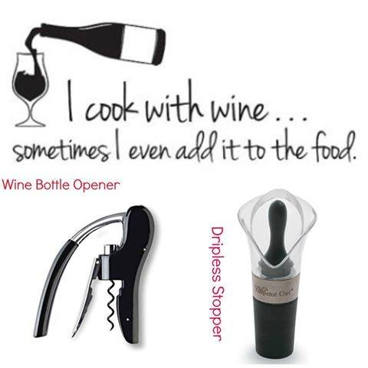
Dripless Pourer Stopper #2158 $11.25
Our exclusive double-lip design ensures dripless pouring of your favorite wine. A tapered end creates a snug fit on most wine bottles, while the stopper fits most wine bottles and acts as a cork, allowing storage even when placed horizontally. Dishwasher-safe.

PRE PARTY POST:
_________________
We are going to have so much fun through HOSTNAMEHERE's LIVE Virtual party! If you haven't done so already, please JOIN by clicking that you are GOING!! (That will get you 1 entry into the drawing!)

PRE PARTY POST:
__________
**BONUS ENTRY POST**
Can't wait for HOST's Virtual Pampered Chef party DATE/ TIME!
I just wanted to give you all a little heads up on how the event will work best for you. (Please comment that you've read this and get a bonus entry/)
1. This event will work best if you are at a computer since it's easier to refresh and receive live updates. if you can't be on a computer- that's ok. Mobile devices are fine, too.
2. REFRESH is your friend! Since FB changes the order of the posts as guests comment, I will number them for you. Refresh throughout the event if you are not getting LIVE notifications of new posts.
3. COMMENTS welcomed! The more participation, the better.
4. LIKE- Please like each post as you are done with it, so that I know when everyone is ready for the next post.
Confused? It’s ok! You'll get the hang of it!

PRE PARTY POST
______________________
If you'd rather place your order now, or if you won't be able to join us for the LIVE event, you can order through this link to support your host's party: PUTSHOWURLHERE
In May, Hosts are able to get 60% off any item in the catalog while guests earn a FREE Spatula. As the May guest special, they can choose one free with a $75 purchase, and $1 is contributed to the American Cancer Society®.
- Large Serving Spatula with White Handle
- Mini Serving Spatula with White Handle
- Large Serving Spatula with Black Handle
- Mini Serving Spatula with Black Handle


PRE PARTY POST:
__________________
Do you know of anybody who loves Pampered Chef, or just loves fun? Why not invite them to this 1 hour LIVE event? You will get bonus entries into the drawing when you invite friends. But PLEASE invite personally...not just ALL your FB friends! Just comment below with how many you invited so that I can give you the appropriate amount of bonus entries!

Pre Party Post
How about some kitchen organization? You can store your cooking tools in plain sight with a Tool Turn-About. The compartments make it easy to organize your most-used tools in the kitchen, office or garage. It’s also a clever way to store craft supplies, hair products and even flatware.
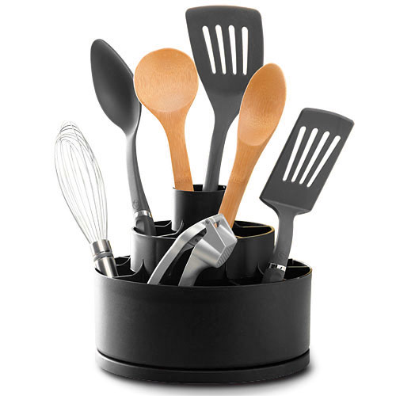
Details
- 8¾" x 7".
- Holds up to 10 lbs.
- Compartments keep tools organized and accessible.
- Has three tiers; the top tier is designed to hold an inverted Food Chopper or other larger utensils.
- Spins for convenient access to tools.
- Complements any kitchen décor and appliances.
- Dishwasher-safe
Cost: $20.00
PRE PARTY POST:
_______________
How would you like to make this AMAZING Chocolate Peanut Butter Cup Cake in 12 minutes!?? Make sure to join the party to see the amazing RockCrok in action, and the recipe for this delicious cake!
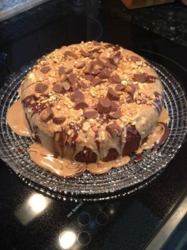
DAY BEFORE PARTY:
___________
Tomorrow is HOST's VIRTUAL party! I can't wait to show you the cool Pampered Chef products. We'll have so much fun with the games and giveaways.
Remember- if you can't make it, feel free to place an online order to support your host's show here: LINK

DAY OF PARTY:
___________
Today's the Day!! I'm so excited for HOST's VIRTUAL party tonight! We will meet back here at: TIME
Please LIKE if you are excited!
Remember- if you can't make the event tonight- please feel free to place an order through this link: SHOWURL

PRE PARTY POST

PRE PARTY POST:
_______________
Check out the gorgeous new color for some of our The Rockcrok® Everyday. It will quickly become your favorite pan!!! The Rockcrok® Everyday Pan is the perfect size for one-pot weeknight dinners. Use it for every cooking method—stovetop, broiler, oven, microwave and grill.
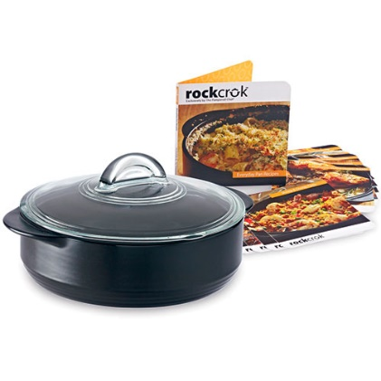
IN COMMENTS:
-9” diameter, 2.5 qts.
-Created from a clay that’s heat-resistant to 752°F, so you can sear, braise, simmer, slow cook, -fry, boil, bake, broil, microwave and grill in one pan.
-Ready to use right away—no pre-seasoning required.
-Even heat distribution makes browning easy.
-Great heat retention—food stays hot long after it’s done cooking.
-Safe for the freezer.
-Goes right from the fridge to the heat.
-Glass lid is oven-safe to 400°F and lets you watch food while it cooks.
-It’s lightweight—a great alternative to cast-iron cookware.
-Dishwasher-safe.
-Includes these 10 exclusive recipe
DAY OF PARTY:
______________
Don't forget- Here's how you can get entries into the GIVEAWAY!!!
How many entries do you have already!?
To get MORE entries, please go back through the event and view the previous posts that you might have missed.

COUPLE HOURS BEFORE PARTY:
_______________
In cased you missed it earlier, here is a reminder on how this works-
1. This event will work best if you are at a computer since it's easier to refresh and receive live updates. if you can't be on a computer- that's ok. Mobile devices are fine, too.
2. REFRESH is your friend! Since FB changes the order of the posts as guests comment, I will number them for you. Refresh throughout the event if you are not getting LIVE notifications of new posts.
3. COMMENTS welcomed! The more participation, the better.
4. LIKE- Please like each post as you are done with it, so that I know when everyone is ready for the next post.
Confused? It’s ok! You'll get the hang of it!


ONE HOUR BEFORE PARTY: (I usually tag all the GOING and MAYBEs on this post- or ask the host to do it)
____________________
ONE HOUR until HOST's Virtual Pampered Chef party!
This will be fast, fun LIVE event with giveaways, games and Pampered Chef awesomeness! Don't miss out on the ON TIME drawing- Don't be late!
If you won't be able to join us live, you can place an order for yourself through this link: URL
Ship to your home, or to the host for pick up!

Pre Show
Ditch the plastic bags for the Everyday Tote Set! These sturdy, stylish and sustainable totes will help you carry groceries and so much more. The two aluminum support bars have clips that hook right onto your shopping cart. You can also use them as gym bags, overnight bags or carry-ons.
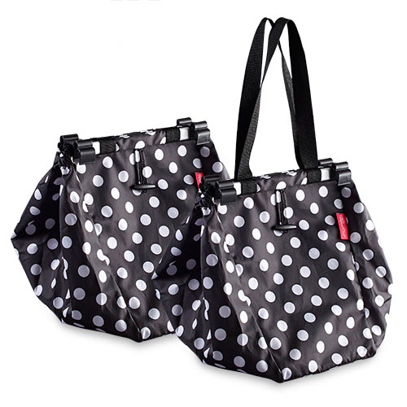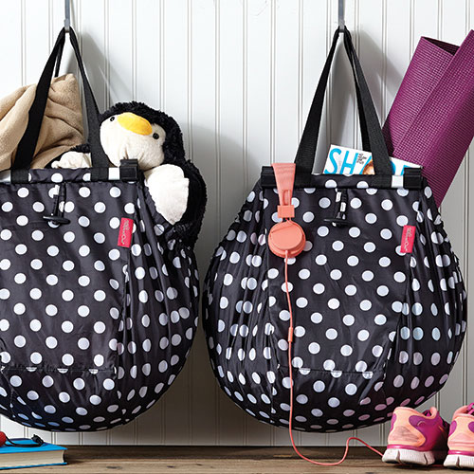

30 MINUTES BEFORE PARTY:
________________________

COMMENTS:
While we are waiting, why don’t we look at some nice dessert items for the spring and summer seasons. Who doesn’t love ice cream, especially when the hot weather gets here….
The pointed head of our Ice Cream Scoop cuts through hard ice cream with ease. The scalloped edges will help you get into the corners of the carton, and all the way to the bottom. The handle will keep your hands from getting cold.
Details
- 7½”.
- Scoop is aluminum with nonstick silicone-based coating.
- Soft-grip silicone and plastic handle.
- Dishwasher-safe.
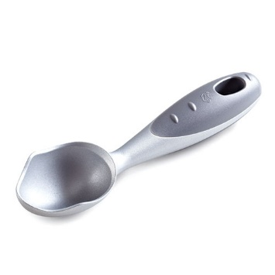
ANOTHER COMMENT
For single servings of ice cream sundaes, salads, stews or snacks. Combine them with the Large and Medium Bamboo Round Bowls for a perfect set; they all nest to take up less space. Set of two. 5¼" diameter; 2½ cups capacity.
Bamboo is a grass, the fastest-growing plant on the planet. This sustainable and renewable resource naturally replenishes itself by constantly sending up new shoots from its root system, so there's no need for replanting. Plus bamboo:
- Doesn't conduct heat.
- Doesn't absorb moisture.
- Is harder and more durable than traditional hardwood.

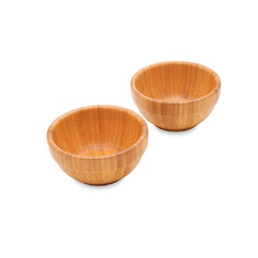

TEN MINUTES BEFORE START TIME:
_____________________
10 minutes until we start!
Grab your favorite drink and get comfy in front of your computer. The on time drawing starts soon.


Right before the show starts:
Everyone wants meal prep to be easier and faster. Here are some things to help and even make dinner a little more interesting and fun!
. Veggie Wedger Item#2417: $18.50
Cut onions, tomatoes, potatoes and citrus fruits into six wedges in one quick motion. Simply place food on the base and use ergonomic handles to press a serrated stainless blade through the food. Includes nonskid base. 5" diameter. Dishwasher-safe.
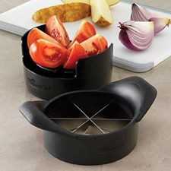

Spiral & Slice $26.50 Item #1136
Spiral-cut your veggies for a new spin on salads, sandwiches and side dishes. Spiral-cut potatoes and onions are to-die-for when deep-fried! Just pop veggies in the base, push on the plunger and twist away for spirals. Use the divider to make half-slices of veggies like zucchini, carrots, celery and pepper strips. Put all your salad fixings in each well and slice right into the bowl. Dishwasher-safe.
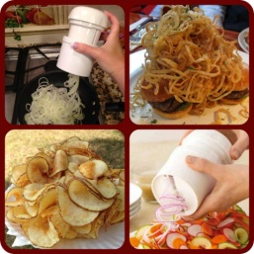

START TIME:
______________
Post 1:
Okay, everyone, it’s finally PARTY time!! Who's excited?? Thanks so much for meeting me back here. I promise a fun, fast, and fabulous way to shop!
Here’s how it works today- I will be posting info about some of our most amazing products, there will be recipes, games, videos and PRIZES! Make sure you are "talking" via comments so you can get more entries. This is an interactive PARTY so the more you comment the better your chances of winning. Please LIKE each post as you have seen it so that I know it's ok to move onto the next one. Please check the comments section of the posts for MORE info and other great info. Checking the comments section of the posts is important, so you don't miss anything.
Don’t worry- the posts will be numbered to help you keep up! If you get lost, just refresh and find the last post you were on.
If you jump on late, just join in.
The on time drawing is up NEXT!!
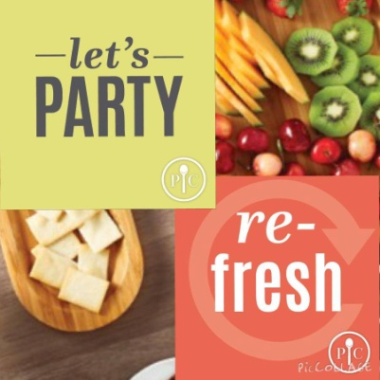

Post 2:
Roll Call!! Who is here partying with us tonight? Please tell us where you're from, and how you know our host! You'll have 2 minutes to "check in" and then I'll pick an ON TIME winner who will get 2 bonus entries into our drawing at the end of the party!


IN COMMENTS:
After two minutes is up, post this:
___________________________
Time's up! Thank you all for checking in, and welcome to the party! I will announce the winner shortly in a comment below!


ANOTHER COMMENT:
And the winner is: GUEST NAME
Congratulations! You will receive 2 bonus entries into the drawing at the end of the party!
Post 3:
**BONUS ENTRY POST**
A few things to know:
When you spend $75 before tax and shipping, you get to choose a FREE gift!!
**Please check the comments section for specials and important info! Comment that you've read it all to receive a BONUS ENTRY into the drawing at the end of the party!
IN COMMENTS:
Our SHIP TO YOUR FRONT DOOR rates have dropped!
If you would like to ship your products directly to your home, make sure to CHANGE THE SHIPPING OPTION when you are placing an order. (Use the drop down next to the items in your cart.)
Shipping to the HOST for pickup is a flat $5.25 charge.
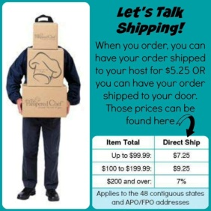

ANOTHER COMMENT:

Did you know we have a 30 day money back guarantee?!
And- every product has a great warranty! Some items are under warranty for 1 year, 3 years, 5 years, or GUARANTEED FOR LIFE!
Pampered Chef stands behind all of it's products! Feel secure when shopping with us!



ANOTHER COMMENT:

At the Pampered Chef, our mission is to bring families around the table again. For some families, that isn't so easy. Please feel free to ROUND UP your order to the next whole dollar because the extra change will be donated to your host's local food bank!! $1 is 9 meals that they are able to put out through Feeding America, so all of your extra change really does make a difference!



Post 4:
Guest Specials for May include 3 ways to whip cancer!
Only in May, you can SHOP and save lives. Here's how you can contribute to the American Cancer Society®.
EARN a free Spatula. As the May guest special, you can choose one free with a $75 purchase, and $1 is contributed.
- Large Serving Spatula with White Handle
- Mini Serving Spatula with White Handle
- Large Serving Spatula with Black Handle
- Mini Serving Spatula with Black Handle
Purchase serving spatulas in May. $1 from the purchase of each spatula is contributed. (Minis are $6.50, Larges are $10.50.)
This is the first time Pampered Chef is offering an exclusive white handle (only in May). And it's also the first time we're dedicating a contribution from a product in the current product line—the black-handled serving spatulas.
Host a Help Whip Cancer® fundraiser party in May. Up to 25% of the party's total sales will be contributed.
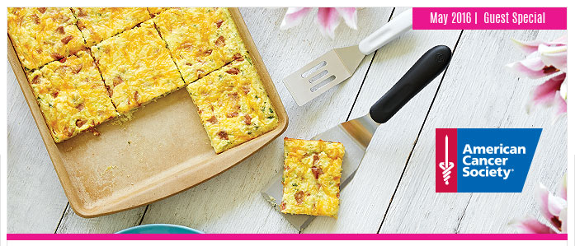
Post 5:
**BONUS ENTRY POST**
How about a quick game to get us started!??
The person who guesses closest without going over will get a bonus entry into the drawing!
Question: How much money did United States citizens spend on paper towels in the year 2015?
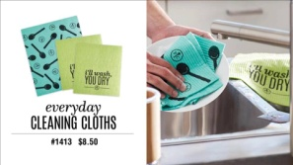

Answer- 1.925 billion dollars in paper towels. That is a lot of money!!!
The Pampered Chef's BRAND NEW Everyday cleaning cloths are a practical way to REPLACE paper towels. They will outlast 15 rolls of paper towels. And these are dishwasher and washing machine safe!
Set of 3 ONLY $8.50
Congrats to GUESTNAMEHERE who guessed closest! You'll get a bonus entry into the drawing!
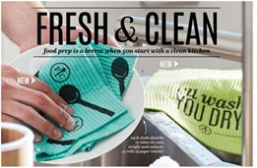
Post 6:
Isn’t it irritating when you are trying to cook and the water keeps boiling over the top of your pot?
Our Boil over no more comes in 2 sizes and is a MUST HAVE! How many of you have turned your back for one second to hear that dreaded HISSING sound of your pot boiling over? And- the horrible mess it leaves on your stove top is the worst!
Small Boil Over No More Item#2422 $25.00
Keep your stovetop spotless. Place over pots and skillets to prevent boil overs and splatters. Removable insert. Silicone. Fits 6"–10" pans and skillets. 10¾" diameter. Heat-safe to 425°F. Dishwasher-, stovetop-, microwave- and oven-safe.
_________________________________
Large Boil Over No More Item#2423 $30.00
lace over pots and skillets to prevent boil overs and splatters. Removable insert. Silicone. Side handles make for easy removal. Fits 8"–12" pans and skillets. 12¾" diameter. Heat-safe to 425°F. Dishwasher-, stovetop-, microwave- and oven-safe.
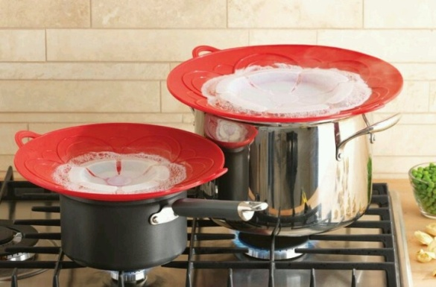
Post 7:
**BONUS ENTRY POST**
Who doesn’t love Brownies? We have an awesome brownie pan that makes the perfect brownies every time.
Our Brownie Pan is perfect for desserts, appetizers and even entrées…especially if you like corner pieces! It’s great for portion control and make-ahead meals.
Details
- 12 individual 2½" x 2½" x 1" wells hold ¼ cup each.
- 16" x 11" overall.
- Nonstick.
- Heavy-duty aluminized steel.
- Hand wash.
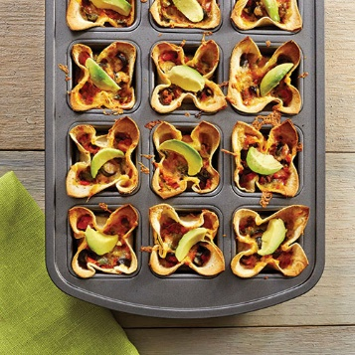
IN COMMENTS:
Stackable Cooling Rack Set helpful for cooling delicious treats without taking up much counter space. I absolutely love mine!
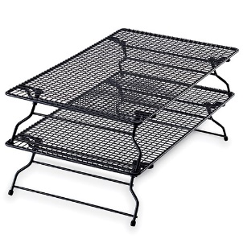
- Set of two.
- 10" x 18" each.
- Durable, heavy-gauge steel with nonstick coating.
- Grid design prevents food from falling through.
- Rubber feet protect counters.
- Hand wash.
Post 8:
Summer is coming up and I am sure we are all going to be hosting or going to a lot of parties!! The next thing is a must have for snacks and treats. We have a wide range of section trays that are great for veggie trays and other delicious delicacies.
The 5-Section Tray converts the Large Square Cool & Serve into a perfect tray for veggies and dip, or a topping bar for burgers, hot dogs, tacos and more. Use the center well for your favorite dip or salsa, and load the side wells with tasty toppings.
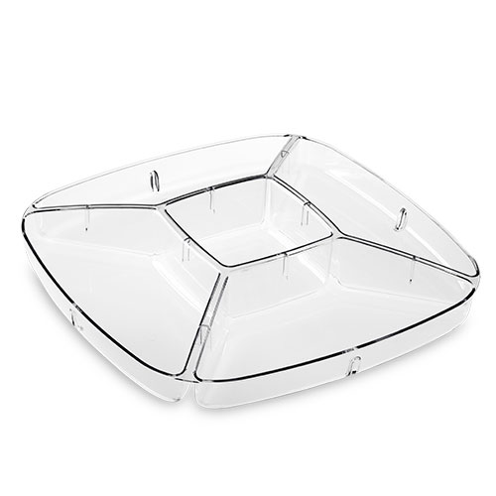
Details
- 11¾" x 11¾".
- Center well holds 1½ cups.
- Fits Large Square Cool & Serve.
- Clear plastic.
- Solid walls.
- Made in USA.
- Dishwasher-safe.
COMMENTS
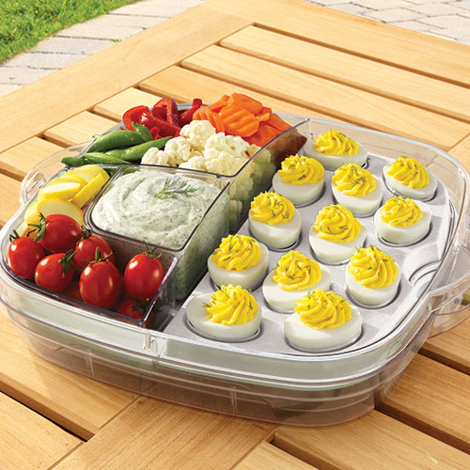
Do NOT copy this part in your live event- Choose 1 of the 5 posts that I will put in a comment below. Copy the QUESTION part of the one you choose, and paste at the end of post #8. Everybody will guess, and then you can copy and paste the top 5 answers into a comment after everybody is done guessing. Make sense? If you have questions- just ask.
___________________________
Post 9:
LET’S HAVE SOME FUN!
It’s time to play Pampered Chef Feud! Guess the TOP answer and earn an entry into the drawing! This game will last for 2 minutes, and then I'll announce the top answers. Everybody who guesses the #1 answer will get a bonus entry into the drawing. Then- we'll move on to the next post!
**ONLY ONE GUESS PER PERSON PLEASE**
Here's the question:
Pick ONE of these questions to post with this game. Then, after everybody is done answering, you can copy the top 5 answers for that question and post as a comment to reveal the answers.
Name A Food That Gets Bigger When It’s Cooked...
1. Pasta (28)
2. Bread (25)
3. Hot Dogs (18)
4. Rice (8)
5. Popcorn (5)
If you hired a gourmet chef to cook for you, name a complaint he might have about your kitchen...
1. Small (54)
2. Pots & Pans (14)
3. Dirty (10)
4. Counterspace (5)
5. Stove (4)
Name a food recognizable by it’s odor...
1. Onions (32)
2. Fish (23)
3. Garlic (11)
4. Pizza (8)
5. Cabbage (6)
Name a food you buy more than one of at a time...
1. Potatoes (24)
2. Eggs (22)
3. Apples (10)
4. Bananas (10)
5. Grapes (7)
Name something you eat by the slice...
1. Bread (36)
2. Pizza (28)
3. Cake (9)
4. Pie (6)
5. Cheese (5)
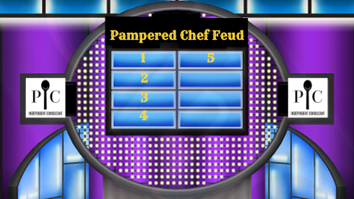

IN COMMENTS:
The top FIVE answers are: COPY ANSWERS TO QUESTION YOU PICKED HERE
Congrats to everybody who guessed the #1 answer! You'll get a bonus entry into the drawing for a FREE gift at the end of this party!

Post 10
A FRESH new look for our favorite pitchers.
A plunge of the handle is all you need to mix up ingredients or to stir the sugars that settle at the bottom of your powdered drinks.
Family-Size Quick Stir Pitcher ONLY $27.50
Quick-Stir Pitcher ONLY $21.50
Our Quick-Stir® Pitchers mix everything from juice and powdered drink mixes to infused water and sangria. You can even mix up a pitcher of your favorite hot drinks, like coffee or tea. The exclusive plunger mixes drinks quickly and easily, and the sleek design fits perfectly with indoor and outdoor table settings, plus it fits right into your refrigerator door.
Details:
BPA free.
Ergonomic handle.
Exclusive mixing plunger design.
Measure markings.
Pour selector.
Made in USA.
Dishwasher-safe.
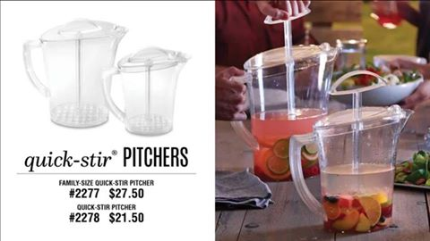

Post 11:
Who loves to cook on the grill?? Check out additional products in the comments section below!
Burger & slider PRESS ~ A handy press that lets you make uniform burgers and sliders at home.
ONLY $14.50
Up your customization game with the Burger & Slider Press. Whether you use beef, turkey, chicken, salmon, veggie burger mix, or prefer stuffed burgers, this handy press lets you make burgers and sliders at home. Change up the meat, seasonings and toppings for burgers that are 100% your style! The uniform size means your burgers will be evenly cooked.
Details:
Burger base creates patties up to ½ pound.
Slider insert creates patties up to 3 oz.
4½" burgers and 3" sliders fit perfectly on store-bought buns.
Dual-sided press creates a “dimple” that keeps burgers flat while they cook.
Flexible base makes it easy to remove pressed patties.
Pieces nest for compact storage.
Dishwasher-safe.
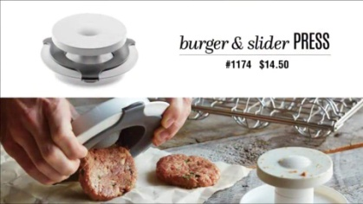

IN COMMENTS:
BBQ Roasting Pan & Can Holder Item #2714 $42.50
Grill meats and vegetables simultaneously. For super-moist chicken, put a 12-oz. can of beer or soda in the detachable can holder and place the chicken on top to barbecue. Small holes and solid side walls keep food contained while turning. Pan, 14" x 12" (35 cm x 30 cm); can holder, 2½" x 4" (6 cm x 10 cm). Dishwasher-safe.

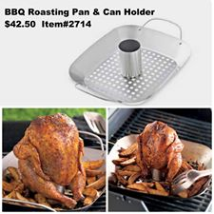

ANOTHER COMMENT:

Meaball and Slider Grill Basket- Makes 12 meatballs or 6 sliders on the grill…and save time by flipping them all at once. ONLY $32.50
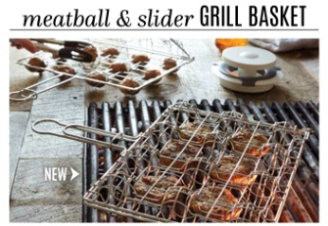
Post 12:
*Bonus entry post! Watch and comment to get an entry into the drawing!*
Video here: https://www.youtube.com/watch?v=a2QL98q27RA
The Quick Slice cuts your favorite fruits and vegetables into even slices with one simple motion. The slices are perfect for snacks, desserts and salads. Try it on tomato, pineapple, cucumber, avocado, fresh mozzarella…even hard-boiled eggs, strawberries and mushrooms.
Details $34.00 Item#1181
8¼" x 5½".
V-shaped blade design keeps food from squishing.
11 serrated stainless steel blades cut 7-mm slices.
Plastic base.
Nonslip feet.
Protective cover.
Dishwasher-safe.

IN COMMENTS:
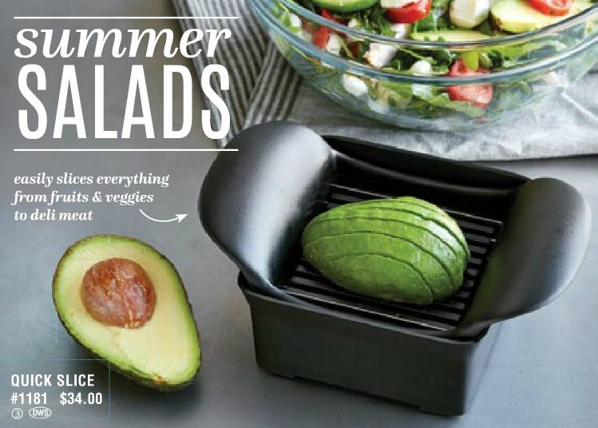
Post 13:
**BONUS ENTRY POST** Video here: https://www.youtube.com/watch?v=mrXfJ0QOEs8 (Watch this SHORT video and comment with your thoughts on it, and get a bonus entry into the drawing!)
The HOTTEST product to hit The Pampered Chef catalog, the market and your kitchen in YEARS! Exclusive to The Pampered Chef (R), this product is AMAZING! It goes in the oven, on TOP of the stove, under the broiler, IN THE MICROWAVE, on the GRILL, and IN THE DISHWASHER! I don't think there is ANYTHING you can't do with this! LOVE IT! Store leftovers in the fridge or FREEZER too!
IN COMMENTS:
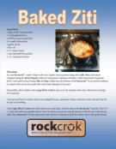
IN COMMENTS:
Chocolate Peanut Butter Cake (only takes 12 minutes to bake!)
Main Ingredients
1 box of Devils Food Cake Mix
3 large eggs
16 ounces of sour cream
½ cup peanut butter
½ cup of chocolate chips
1 small bag peanut butter cups
1. Open 1 box of Devils Food Cake mix. Empty into Stainless Steel Mixing Bowl. Crack 3 eggs into 3 Cup Prep Bowl. Add to cake mix. Add 16 ounces of Sour Cream using Classic Scraper to cake mix. Mix well with Mix ‘N Masher until blended.
2. Spritz Dutch Oven Rockcrok with Kitchen Spritzer and pour ½ batter in the bowl.
3. Unwrap peanut butter cups and chop with Food Chopper on Cutting board. Sprinkle half of chopped Peanut Butter cups and top with remaining batter.
4. Cover and place Rockcrok in microwave for 12 minutes.
5. Let sit for 10-15 minutes with the cover removed on Stackable Cooling Rack.
6. Measure peanut butter in Measure All Cup & MicroScraper and place in SiliconePrep Bowl. Measure ½ cup of chocolate chips and place in Prep Bowl. Microwave until melted stirring every 30 seconds.
7. Place Shimmering GlassPlatter on top of baker and flip cake out using Oven Mits.
8. Drizzle melted peanut butter and melted chocolate over cake. Top with remaining chopped PB Cups.
9. Serve with Slice ‘N Serve.
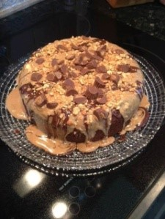
ANOTHER COMMENT:
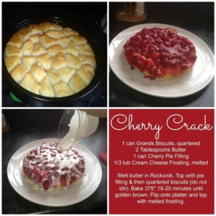
Post 14:
We are famous for our STONEWARE! Please comment below with what pieces of stoneware you have, and why you would recommend them! And check the comments section for some of our BRAND NEW stones!
About Stoneware:
No preheating — just place food on Stoneware and cook. (Dense frozen foods like meat should be thawed first.)
Absorbs and retains heat for even baking and golden crusts.
Draws moisture away from food so it cooks light and crispy.
Virtually nonporous, so it doesn’t retain oils, odors or flavors.
Microwave-, freezer-, conventional and convection oven-safe.
Nonstick “seasoning” builds up with every use: the darker it looks, the better it cooks!
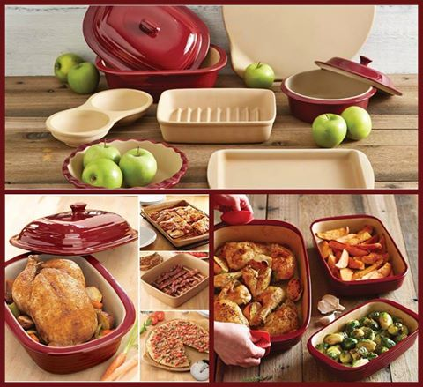

IN COMMENTS:

Check out the gorgeous new color for some of our STONEWARE!! Be sure to see comments for MORE Stoneware updates!
Rectangular BAKER SET-NEW Our classic stoneware is a brand new neutral-graystone.
Small-9X6, 4 cups
Medium-11X7, 8 cups
Large-9X13, 14 cups
ONLY $125.00 - set of 3
Rectangle Baker 9x13 - $51

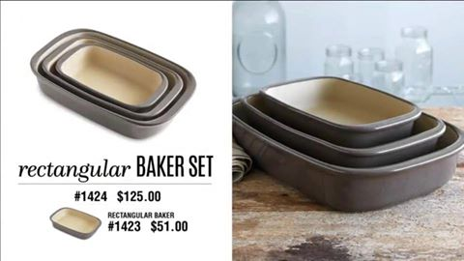
Post 15
**BONUS ENTRY POST**
Last game for the night. The person to get the correct answer will get 3 each entries into the drawing at the end of the show. Everyone who gets the correct answer will win the entries! Here is goes, food trivia:
Pick one question from below:
What gives green pasta its color?
A: Spinach.
What part of a cola tree is used to flavor beverages?
A: Nuts.
What type of flowers produce vanilla pods?
A: Orchids.
Which variety of hard green-skinned apple is named after an Australian woman who died in 1870?
A: Granny (Maria Ann) Smith.
Which edible bulb of the onion family is composed of small segments called cloves?
A: Garlic.

IN COMMENTS:
The correct answer is:
The winner(s) are:
Post 16
**BONUS ENTRY POST**
I hope you've seen a lot of things that you just have to have! By hosting your OWN virtual party- just like this one, you can get an average of over $115 in FREE products of your choice! (Avg of $130 in March!) Also- you'll get up to 5 50% off items, and an unlimited 20-30% discount on anything else you might.
**Plus- your host gets a 50% off bonus when you book your party!!
Please comment below if this is something you might want to try!!
I do ALL the work and you just have to invite your fb friends. So easy- and so FUN!
Comment below if you'd like to give it a try, and you'll 5 BONUS ENTRIES into the drawing at the end of the party!

Post 17:
We are wrapping up now, but don’t go anywhere yet! Here's a chance to get lots of bonus entries before I pick a winner!
Q&A Time!!! **1 bonus entry into the drawing for every question you ask about the Pampered Chef business!**
******************
Could you use an extra $500+ a month? Did you know that you can be a Pampered Chef consultant, and only do ONLINE parties like this one!?
Check out this KIT you get when you become a consultant! Yours to keep no matter what- whether you're a consultant for a month, or forever!
Over $600 worth of products for only $159!! (Or- go with the mini kit for $99)
We are looking for ONLINE consultants, cooking show consultants, freezer meal workshop consultants, catalog consultants and fundraiser consultants! (Or- any combination- whatever works for you!)
No pressure- and so easy. Give it a try and see if you like it. (I will help you with everything!)
If not- no big deal. Simply walk away and KEEP the kit!!! It doesn't get any more 'no risk' than that!
Please comment and let me know if you'd like me to message you some info!
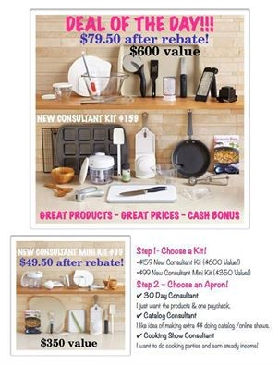
Post 18:
Last chance for 5 BONUS ENTERIES!
Who LOVES Pampered Chef, and LOVES free! Let's hook you up with your own Pampered Chef party! Let's pick a night when you have an hour free and do a VIRTUAL party like this one! You'll get an average of $115 in free products, and up to 5 50% off items of your choice, an unlimited 20-30% discount on anything else and a 10% discount for all future purchases in the next year!
Your host will get a BONUS when you book your own party, too!
Comment below if you'd like to book a party and get FIVE BONUS ENTRIES into the drawing at the end of the party!

Post 19:
Thank you so much to everybody for joining us tonight and an extra special THANKS to our host! I hope you all saw a lot of things you loved.
The Virtual Party is over and it's time to SHOP! All orders that come in help your host get FREE Pampered Chef! Remember- spend $75 to receive the FREE Guest Special.
To place your order, visit this link: SHOWURL
Please let me know if you have any questions, and again- THANK YOU for partying with us!
The winner from the party tonight will be announced on the next post.


Post 20:
And the winner is: GUESTNAMEHERE
Congratulations!! I will add your prize onto your order!
Thank you all again for participating tonight! Remember- orders can be placed through this link to support your host: SHOWURL
If you have any questions, please let me know.

IMMEDIATELY FOLLOWING PARTY POST:
Post 21:
In case you are just joining us!
- Posts are numbered so you can make sure you've seen them all.
- Many posts have more details &/or recipes in their comments, so be sure
to check!
- Here is the online party link: SHOWURL
Last Day to order is DATE!
- You will get a set of 2 prep bowls for any order over $75 before tax and shipping.
- YOU can schedule your own party - catalog OR online/Virtual Facebook party like this one OR an in-person party if you live in the Reno, NV area. There is a host bonus every month in addition to the generous host program including FREE items 1/2 price items and unlimited additional discounts. And a 10% discount for an entire YEAR!
- When you book a party of any kind, our host will get to choose a ½ price item at YOUR party!

AFTER PARTY POST:
Don't forget to place your orders! Only a couple days left before we close out the party!
Orders to support your host can be placed here: SHOWURL


AFTER PARTY POST:
It's not too late to book a Pampered Chef ONLINE party!! We can book anytime through March and your host will still get the bonus, so don't feel like you need to book it ASAP if the timing doesn't work for you. Let's surprise your host with a BONUS 50% off for her!

AFTER PARTY POST:
____________
Don't forget to place your orders! Only a couple days left before we close out the party!
Orders to support your host can be placed here: SHOWURL


DAY BEFORE OR DAY YOU ARE CLOSING PARTY:
ONLY ONE MORE DAY to place your orders. If you haven't done so yet, please click this link to order and support your host's party: SHOWURL
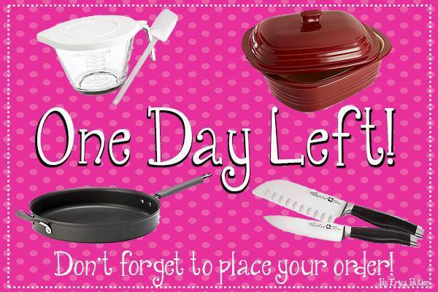

HOUR OR TWO BEFORE YOU CLOSE PARTY:
________________________
Ok- LAST CALL for orders! If you haven't gotten a chance to order yet, please do so through this link to support your host's party: SHOWURL


Don’t forget to thank each person for their order and support!!

ONCE ITEMS SHIP:
_____________________
Good news! Your products have shipped! Be on the lookout for your Pampered Chef.


