RECIPE COLLECTOR
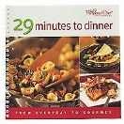
#2453 TPC Make It Fresh, Make It
Healthy 15.50
#2499 TPC Festive Holiday Cookie
Card Collection 3.50 Basic Total: $19.00
#2227 TPC 29 Minutes To Dinner 15.50
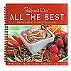
#1978 TPC Seasons Best
Recipe Collection 2.00
Deluxe Total: $34.50
#2214 TPC All The Best 15.50
#2459 TPC Great Grilling Recipes 15.50 Ultimate Total: $65.50

CUTTING EDGE ESSENTIALS
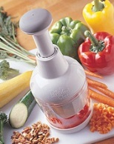
#1258 Quikut Paring Knives (Set of 3) 6.00
#1012 Cutting Board 18.50
Basic Total: $24.50
#1074 Color Coated Paring Knife 13.50
Deluxe Total: $38.00
#2585 Food Chopper 33.00
Ultimate Total: $71.00

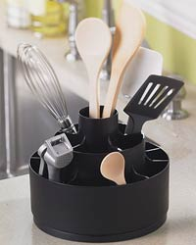
USEFUL TOOLS
#2583 Mix ‘N Chop 11.50
#1166 Slice 'N Serve® 9.00
#1101 Hold 'N Slice® 6.00
Basic Total: $26.50
#1755 Chef’s Silicone Basting Brush 10.00
#1071 Vegetable Peeler 9.50
Deluxe Total: $46.00
#2171 Tool Turn-About 19.50
Ultimate Total: $65.50

HOLIDAY DINNERS

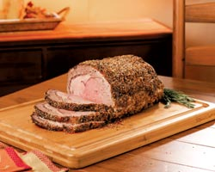
#2715 Meat Lifters 29.00
#2248 Pocket Thermometer 13.00
Basic Total: $42.00
#1665 Baster & Cleaning Brush 13.50
Deluxe Total: $55.50
#1005 Reversible Bamboo
Carving Board 73.50
Ultimate Total: $129.00

PARTY TIME

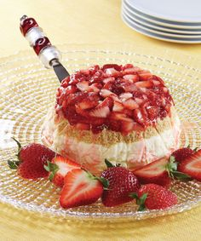
#3114 Small Square Bowl and
Caddy Set 29.50
#2048 Bamboo Serving Set 9.50
Basic Total: $39.00
#1369 Garlic & Brie Baker 29.50
#2001 Shimmering Glass
Round Platter 38.00
Deluxe Total: $106.50
#2439 Bamboo Appetizer Platter 24.00
#2836 Ice Bucket & Scoop Set 41.50
Ultimate Total: $172.00

MUFFIN MAN
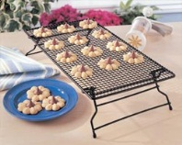
#1606 Deluxe Mini-Muffin Pan 18.00
#1590 Mini-Tart Shaper 6.50
#2530 Small Scoop 16.00
Basic Total: $40.50
#1465 12-Cup Muffin Pan 38.50
#1790 Large Scoop 18.00
Deluxe Total: $96.00
#1587 Stackable Cooling Rack 16.50
Ultimate Total: $112.50

THE BAKER
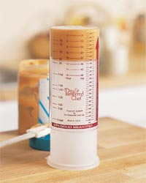
#2431 Classic Batter Bowl 17.50
#1659 Small Mix 'N Scraper® 13.50
Basic Total: $31.00
#2258 Adjustable Measuring Spoons 9.00
#2225 Measure-All® Cup 11.00
Deluxe Total: $51.00
#2175 Easy Read Measuring Cups 24.00
#2177 Easy Read Mini Measuring
Cup 6.50
Ultimate Total: $81.50

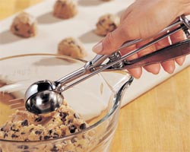
COOKIE LOVER
#2540 Medium Scoop 17.00
#2622 Mini-Serving Spatula 6.50
Basic Total: $23.50
#1521 Cookie Sheet 19.00
Deluxe Total: $42.50
#1588 Stackable Cooling
Racks (set of 2) 29.50
Ultimate Total: $72.00

THE DECORATOR

#1585 Decorator Bottle Set 14.00
#1095 Creative Cutters Set 12.50
#1695 Flour/Sugar Shaker 7.50
Basic Total: $34.00
#1778 Easy Accent® Decorator 25.00
Deluxe Total: $59.00
#1526 Cookie Press 32.50
Ultimate Total: $91.50

PIE LOVERS
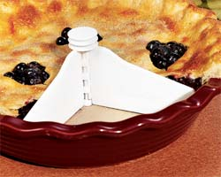
#1332 Deep Dish Pie Plate 36.50
#1695 Flour/Sugar Shaker 7.50
Basic Total: $44.00
#1715 Pie Crust Shield 8.50
#1686 Pastry Blender 9.00
Deluxe Total: $61.00
#1485 Baker's Roller® 19.50
#1166 Slice 'N Serve® 9.00
Ultimate Total: $89.00

ALL Pampered Chef® products have three prices: Full Price, Half-Off, and FREE.
Contact me for details on how to get the
price you would like to pay.
Scott Backus (425) 463-9842 text or cell


Gift Ideas from your
Pampered Chef® Consultant!
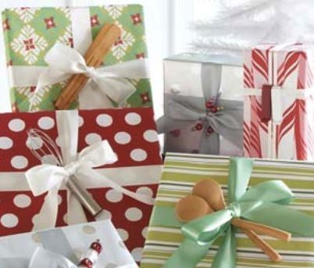

Great Ideas For:
House Warmings, Weddings, Showers, Birthdays, Anniversaries, Christmas,
Or Any Occasion!!

Choose from 3 different package sizes depending on how much
you want to spend! You have the choice of the Basic, Deluxe, or Ultimate! Or you can mix and
match to create your own!

Prices are subject to change and do not reflect
any current monthly special. Prices are current
as of September 1, 2014

Your Pampered Chef Consultant:
Scott Backus (425) 463-9842 text or cell
ScottCooks@hotmail.com
www.PamperedChef.biz/Scott

www.facebook.com/
scott.cooks.w.pampered.chef
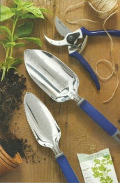
GREEN THUMB
#1235 Garden Trowel 24.00
#1237 Garden Weeder 15.00 Basic Total: $39.00
#1239 Garden Pruning Shears $29.50
Deluxe Total: $68.50
#1236 Garden Cultivator $24.00
#1238 Garden Transplanter 24.00
Ultimate Total: $116.50

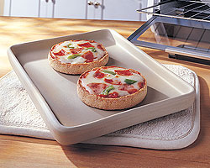
THE WORKPLACE
#2776 Small Micro-Cooker® 9.00
#2759 Smooth-Edge
Can Opener 21.50
Basic Total: $30.50
#2427 Apple Wedger 14.50
#1260 Citrus Peeler 1.25
Deluxe Total: $45.25
#1001 Bar Boar 10.50
#1250 Quikut Paring Knife 2.50
#1448 Toaster Oven Pan 19.00
Ultimate Total: $76.25

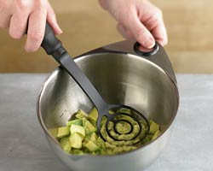
WITH SMALL KIDS
#2685 Mix ‘N Masher 11.50
#1195 Cut-N-Seal® 11.00
#2904 My Safe Cutter 4.75
#1642 All-Purpose Spreader 6.00
Basic Total: $33.25
#2427 Apple Wedger 14.50
#2759 Smooth-Edge Can .
Opener 21.50
Deluxe Total: $69.75
#2585 Food Chopper 33.00
Ultimate Total: $102.75

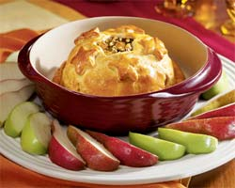
COLLEGE STUDENT
#2776 Small Micro-Cooker® 9.00
#2759 Smooth-Edge
Can Opener 21.50
Basic Total: 30.50
#1001 Bar Board 10.50
#1250 Quikut Paring Knife 2.50
#2651 Twixit! Clip Combo Pack 6.00
Deluxe Total: 50.50
#1337 Mini-Baker 28.50
Ultimate Total: $78.00

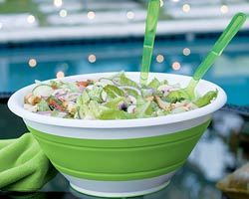
FRUIT SALAD
#2427 Apple Wedger 14.50
#1260 Citrus Peeler 1.25
#1176 Core & More 12.00
Basic Total: $27.75
#1001 Bar Board 10.50
#1161 V-Shaped Cutter 10.50
Deluxe Total: $48.75
#2792 Collapsible Serving Bowl 27.50
Ultimate Total: $76.25

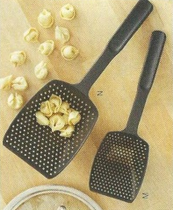
ITALIANA

#2576 Garlic Press 17.50
#9719 Italian Seasoning Mix 6.50
Basic Total: $24.00
#1622 Scoop 'N Drain 11.50
Deluxe Total: $35.50
#1129 Adj. Coarse Grater 35.50
Ultimate Total: $71.00

PIZZA LOVER
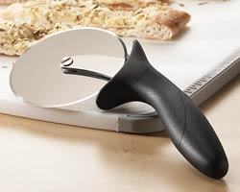
#1302 Pizza Cutter 11.50
#9051 Pizza Crust Mix
(#9053 Gluten Free +$2) 8.00
Basic Total: $19.50
#1371 Large Stone
With Handles 34.50
Deluxe Total: $53.00 #9719 Italian Seasoning 6.50
#2576 Garlic Press 17.50
Ultimate Total: $77.00

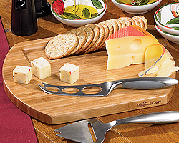
WINE & CHEESE LOVER
#1003 Reversible Bamboo
Cheese Board 27.50
#1642 All Purpose Spreader 6.00
Basic Total: $33.50
#2158 Dripless Pourer/Stopper 11.00
Deluxe Total: $44.50
#2199 Wine Bottle Opener 34.00
Ultimate Total: $78.50

MARGARITA LOVER
#1001 Bar Board 10.50
#1250 Quikut Paring Knife 2.50
#2272 Quick Stir Pitcher ® (2qt)18.50 Basic Total: $31.50
#2424 Drink Rimmer Set 19.50
#2595 Citrus Press 19.50
Deluxe Total: $69.50
#2298 Ice Bucket/Scoop Set 41.50
Ultimate Total $108.00

ENTERTAINING
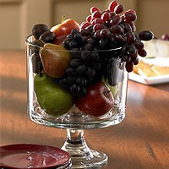
#2296 Bamboo Sm Snack Bowls 19.50
#2047 Small Bamboo Spoon Set 6.00
Basic Total: $25.50
#2247 Bamboo Cracker Tray 16.50
#2001 Shimmering Glass Round
Platter 34.50
Deluxe Total: $76.50
#2832 Trifle Bowl 40.00
Ultimate Total: $116.50

If you fell in love with more than a few of these items, you can get them free! Host a party, earn free products of your choice and a discount! Contact me today!
Scott Backus (425) 463-9842 text or cell
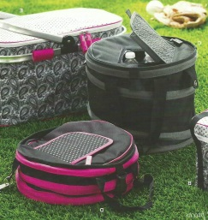
ON-THE-GO

#1202 3-cup Square Leakproof
Glass Container (LPGC) 14.00
#1201 1½-cup LPGC 11.00
Basic Total: $25.00
#2328 Double Wall Tumbler 10.00
#1212 Insulated Lunch Tote 12.50
Deluxe Total: $47.50
#1218 Insulated Collapsible
Cooler 36.00
Ultimate Total: $83.50
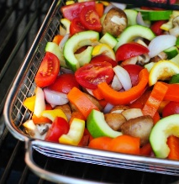
GRILLIN' OUT
#2718 BBQ Corn & Skewer Rack 18.00
#2704 BBQ Basting Bottle 17.00
Basic Total: $35.00 #2707 BBQ Grill Basket 29.50
Deluxe Total: $64.50
#2696 Barbecue Mitt 18.50
#2455 Corn Cob Nobs 5.00
Ultimate Total: $88.00

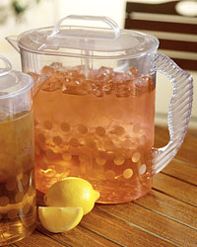
SUMMER CHILLIN'
#2792 Collapsible Serving
Bowl (8 Qt) 27.50
#2569 3-Way Tongs 12.00
Basic Total: $39.50
#2274 Family-Size Quick
Stir Pitcher (1 gal) 24.50
Deluxe Total: $64.00
#2292 Cool N Serve Tray 46.50
Ultimate Total: $110.50

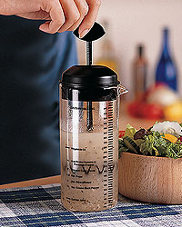
SPIN ON SALADS
#2582 Salad Chopper 27.50
#2265 Measure, Mix & Pour 13.00
Basic Total: $40.50
#1136 Spiral & Slice 26.00
Deluxe Total: $66.50
#1785 Salad & Berry Spinner 60.50
Ultimate Total: $127.00

KEEP IT CLEAN
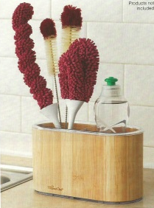
#1688 Decanter/Bottle Cleaning
Brush 9.00
#1634 Glass Cleaning Brush 9.00
#1624 Soft Tip Cleaning Brush (2) 7.00
Basic Total: $25.00
#1625 Easy Clean® Kitchen Brush 9.50
#1681 Corn & Veggie Brush 10.50
#1689 Dual Sided Cleaning Brush 4.50
Deluxe Total: $49.50
#1716 Bamboo Sink Caddy 22.50
Ultimate Total: $72.00

