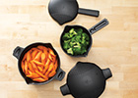
Micro-Cookers –
Small #2776- $9.50
Large #2778-$12.00
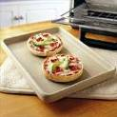
Heating up soups ….cooking macaroni and cheese, ramen noodles…or to make a “pot of tea” in the microwave!
Stoneware Bar Pans –
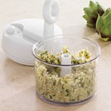
Toaster Oven #1448- $19.00
Medium #1449- $26.50
Use in oven, microwave, or toaster oven. Cook up bacon, hot pockets, reheat pizza, Pronto Mini Pizzas (recipe included), or bake 4 ready-made cookies or an individual sized frozen pizza.
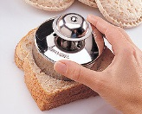
Cut N Seal #1195 – $11.00
Make your own hot pockets and crustless P&J sandwiches!
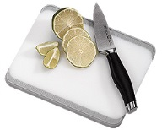
Small Bar Board #1001– $11.00
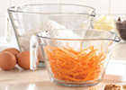
Small cutting jobs, easy to store
Batter Bowls –
Small #2432- $15.00
Classic #2431- $18.50
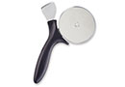
Tuna and noodles in the microwave… mixing bowl, storage bowl for leftovers. You’ll use them for everything!
Pizza & Crust Cutter #1303 - $15.00 Oversized wheel glides through any size pizza. Great for quesadillas, garlic bread and brownies too.

Jane Suprise #560731
920.574.2561
ChefJane70@att.net
www.pamperedchef.biz/jsuprise

Apple Wedger #2427 – $15.00
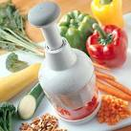
Promotes healthy snacking (apples, pears)
Food Chopper, Manual Food Processsor
Food Chopper #2585 - $34.00
Manual Food Processor #2593 - $52.50
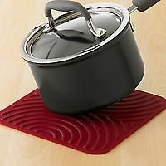
Save yourself time so you have more time to study! Opens up for thorough cleaning. (No science projects in the kitchen!) Great for apartment living too, when you have to do all your own cooking!
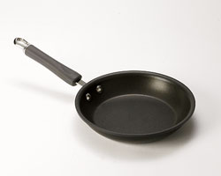
Hot Pad/Trivet #1263 - $12.00 Use as an oven pad, a trivet, and to open jars
8” Sauté Pan nothing sticks, perfect size
Executive #2863 – $52.00
Lifetime Guarantee
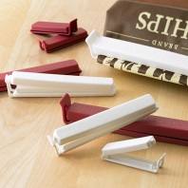
Twixits! #2651 – $6.50

Mandatory for closing bags of chips, pretzels, frozen waffles, or the bag of dirty laundry…also good for identifying your tube of toothpaste.

Quik Stir Pitcher #2272 – $19.50
Mix up OJ, or iced tea…will fit in fridge. Designed for hot or cold beverages

Round Covered Baker #1364 - $52.00 a “baby” version of our Deep Covered Baker great for any kitchen! Perfect for dinner for two, sides for four or dessert for six.
Dorm Room Survival/
Apartment Survival

Essential First Kitchen suggestions from your
Pampered Chef® Consultant!

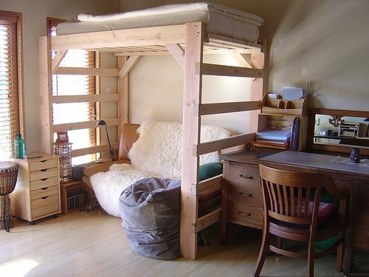

The Dorm Room Survival guide has some great products that are perfect for someone in a dorm or apartment. Take some time to look through and see what products could be helpful in your dorm/apartment.

**Prices are subject to change and do not reflect any current monthly special. Prices are current as of September 1, 2015

Your Pampered Chef Consultant:

Jane Suprise #560731
920.574.2561
ChefJane70@att.net
www.pamperedchef.biz/jsuprise
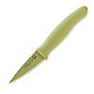
Knives
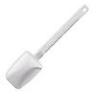
Color Coated Paring Knife #1074 - $14.00 corrosion-resistant stainless steel blade with a nonstick coating and protective cover
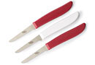
Quikut Paring Knives #1258 - $6.00 Dishwasher safe, 2½” blade (set of 3)

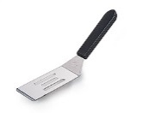
Mini Serving Spatula #2622 – $6.50
#2438 - $4.00 (mini nylon)
Dish up those brownies easily, perfect small size
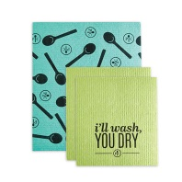
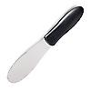
All Purpose Spreader #1642– $6.00
For spreading margarine, peanut butter, jam, icing, mayo, etc.
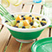
Collapsible Serving Bowl #2794 - $17.50
When collapsed – fill with dip in the middle and chip or crackers around the outside. Will hold snacks and stay fresh with the lid on. Folds flat for easy storage.
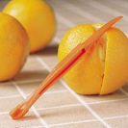
Citrus Peeler #1260 – $1.25
Won’t break a nail opening oranges or grapefruit!
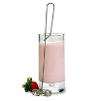
Mini Whipper #2635 – $5.25
Whip up chocolate milk and anything else that you need a whisk for
ALL Pampered Chef® products have three prices:
Full price, Half-Off, and FREE. Contact me for details on the price you would like to pay.
Jane Suprise 920.574.2561
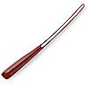
Scrapers
Micro Scraper #1702 - $13.50
Skinny Scraper #1655 - $9.50
Small cans, peanut butter jars, stirring, can’t melt it.
Small Mix N Scraper #1659 – $13.50
Mini Mix N Scraper #1656 - $10.50
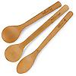
More like a spoon and spatula in one! Can use in cookware and won’t melt!
Bamboo Spoons
#1674 – $11.00
Won’t stain or crack

Everyday Cleaning Cloths #1413 – $8.50
Cut back on waster and save money! These cute cloths outlast 15 rolls of paper towels! Great for washing dishes, spills, and other general cleaning projects
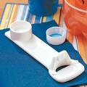
Easy Opener #2590 – $6.25
Open up jars, sodas, bottles much easier, sticks on your dorm fridge

Garlic & Brie Baker #1369 - $31.00
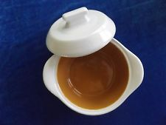
(great covered soup bowl) Perfect size dishes for one, easy to store and stack, guaranteed, break and chip resistant, can microwave in them

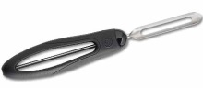
Vegetable Peeler #1071 - $9.50
perfect for fruits and vegetables

If you fell in love with more than a few of these items, you can get them free! Host a party and you can earn free products of your choice!
Contact me today! 920.574.2561

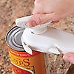
Can Opener #2759 – $21.50
Won’t rust, easier to use, won’t have to replace it in a year because it won’t turn, no sharp edges
Tool Turn-About #2171 – $19.50
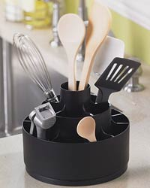
Fill it with the remaining items on this page! Use some compartments for desk/craft supplies, too (scissors, pens, ruler, glue stick, highlighters, etc.)!
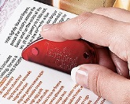
i-Slice #2997 $4.50
Great for opening CD’s, DVD’s, cutting coupons, scrapbooking, magnetic

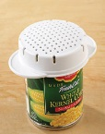
Can Strainer #2495 - $6.00 Strain cans without getting the juice all over. Flip it over and strain tuna with ease.

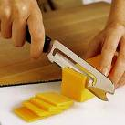
Cheese Knife #1126 - 10.50
No small wire to break! You won’t have to replace this, works much better than a knife.
Please call if you’d like to learn more about The Pampered Chef® opportunity. It’s so easy to try on our apron, and flexible enough to work alongside any schedule.
I love what I do…
maybe it’s right for you, too!

Jane Suprise #560731
920.574.2561

