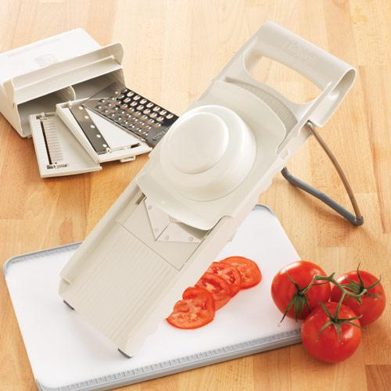
- Go to www.pamperedchef.biz/XXXXX

- Click on create an account in the upper left corner

- You will need to create an account/ Fill in your contact info and create a password.

- It will ask you to search for a consultant. Enter Consultant name and State.

- After you create your account, click on the box in the upper left corner and search for your hostess (if you are part of a party). Click on their name and start shopping!
How to Order from My Website


Consultant Name
5432 Any Street West
Townsville, State 54321

(543) 555-0150 www.pamperedchef.biz/XXXXX


Please call if you have any questions.
Make sure to use a valid email to receive your receipt.

Please call If you need further assistance
Consultant Name

