Description: lceeidns[1]

**For mixing formula:**

*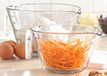Classic Batter Bowl* (2 qts) #2431 $18.50



*Small Batter Bowl* (1 qt) #2432 $15.00

*Quick-Stir Pitcher* (2 qts)

#2277 $21.50



*Family-Size Pitcher* (1 gal)

#2278 $27.50

*Mini Whipper* #2635 $5.25

[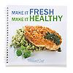](https://www.pamperedchef.com/ordering/prod_details.tpc?prodId=33222&catId=7&parentCatId=7&outletSubCat=)***Make it Fresh, Make it Healthy*** cookbook – #2453 $15.50

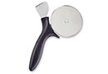Helps you get back into your old wardrobe, while cooking healthy food for your family.

**Pizza & Crust Cutter** #1303 - $15.00 Quickly cut young children’s food into bite-size pieces, then eat yours while it‘s still warm. Great for pancakes, French toast, waffles, spaghetti, fruit, anything at all!

**Pocket Thermometer** –

#2248 $13.50 Check the temperature in baby’s bottles or bath water.

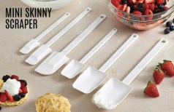**Scrapers** – Perfect for getting every last drop out of baby food jars!

#1704 Mini Skinny Scraper $7.50

#1655 Skinny Scraper $9.50

**Jane Suprise** #560731

920.574.2561

ChefJane70@att.net

www.pamperedchef.biz/jsuprise

Description: lceeidns[1]

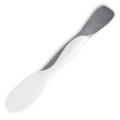**Scoop & Spread** - #1708 $8.50 Scoop, scrape, spread & slice with one tool! Making sandwiches (PB&Js) has never been easier!



[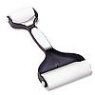](https://www.pamperedchef.com/ordering/prod_details.tpc?prodId=363&catId=122&parentCatId=122&outletSubCat=)**Baker’s Roller**® - #1485 $19.50 Highly recommended for labor pain massage and baby massage later!

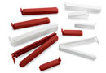**Twixit! Clips** - #2651 $6.50 

Great for closing breast milk pump bags, sealing bags of cereal, or making an impromptu bib with a restaurant napkin!

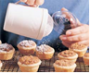[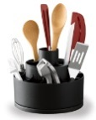](javascript:openLargeImage())**Tool Turn About** - #2171 $20.00 Organize baby’s diaper changing and bath supplies – add a strip of wallpaper border to the base to coordinate with baby’s room!

**Flour/Sugar Shaker** - #1695 $7.75 for cornstarch instead of baby powder

[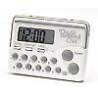](https://www.pamperedchef.com/ordering/prod_details.tpc?prodId=198&catId=122&parentCatId=122&outletSubCat=)**Clock/Timer** - #1900 $17.00 Set to time nursing on each breast, to help you wake up for nighttime feedings, for Time Outs for older children, for sharing toys – switch when the beeper goes off, for a potty training reminder.

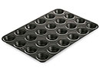**Mini Muffin Pan & Mini Tart Shaper**

*Mini Muffin Pan* #1606 - $18.00

*Mini-Tart Shaper* #1590 - $6.50

Kids love treats that are their size – Little Jell-O servings, muffins and cupcakes for them, terrific appetizers for you when entertaining!

**Baby Essentials**

Product suggestions for Parents from your Pampered Chef® Consultant!

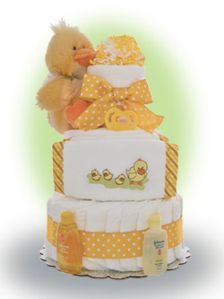

The Baby Essentials guide has some great products that are perfect for all parents; from parents-to-be to parents of toddlers and preschoolers. Take some time to look through and see which products could be useful for your family.

**Prices/Products are subject to change and do not reflect any current monthly special. Prices are current as of

March 1, 2016

Your Pampered Chef Consultant:

**Jane Suprise** #560731

**920.574.2561**

ChefJane70@att.net

www.pamperedchef.biz/jsuprise

Description: lceeidns[1]

**Babies don’t stay little for long; we want to enjoy them for every moment possible. Here are some Pampered Chef® products that will hasten the chores that come with kids so you savor your time with them.**

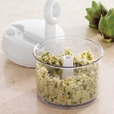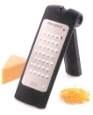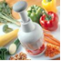**Manual Food Processor, Food Chopper, Cheese Graters, and Garlic Press** Make your own baby food from table food! Pasta, cooked carrots, etc. YOU control how fine you want it for your baby… Later, you can “hide” healthy food by chopping or grating it finely so no one will even know it’s there in the muffins or meatloaf!

*Manual Food Processor* #2593 - $52.50

*[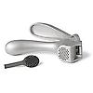](https://www.pamperedchef.com/ordering/prod_details.tpc?prodId=26463&catId=123&parentCatId=123&outletSubCat=)Food Chopper* #2585 - $34.00

*Microplane Fine Grater* #1105 - $29.50

*Microplane Coarse Grater* #1129 - $36.50

*Garlic Press* #2576 - $18.00

[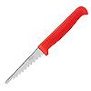](https://www.pamperedchef.com/ordering/prod_details.tpc?prodId=9761&catId=90&parentCatId=90&outletSubCat=)**My Safe Cutter** #2904 - $4.75

Kid-friendly cutter, rounded point, just sharp enough for apples, cheese, pancakes.

If you fell in love with more than a few of these items, you can get them free! Host a party and you can earn free products of your choice!

Contact me today! **920.574.2561**

[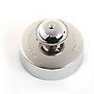](https://www.pamperedchef.com/ordering/prod_details.tpc?prodId=33&catId=90&parentCatId=90&outletSubCat=)**Cut ‘N Seal** #1195 - $11.00

Make pocket sandwiches and remove the crust at the same time (freeze those crusts for stuffing, breakfast casseroles, feeding the ducks, etc.) Make full circle sandwiches with 2 slices of bread or dough (“flying saucer sandwiches” that contain PB&J, taco meat & cheese, etc.). Make semi-circles (“Peanut Butter Moons”) by putting filling on one slice of bread, fold diagonally, cut away the crust and seal!

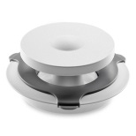

**Burger/Slider Press –** #174 $14.50 Make your own burgers/sliders at home with your favorite ingredients quickly and easily!

[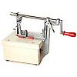](https://www.pamperedchef.com/ordering/prod_details.tpc?prodId=229&catId=90&parentCatId=90&outletSubCat=)**Food Storage –** Store prepared ingredients, reheat food in the microwave, store leftovers and more. Tempered glass is dishwasher-, freezer-, microwave-, and oven-safe to 350oF

[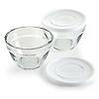](https://www.pamperedchef.com/ordering/prod_details.tpc?prodId=27468&catId=123&parentCatId=123&outletSubCat=)**Prep Bowls** – #1825 1-cup (set of 6) $22.00

#1742 2-Cup (set of 2) $16.50

#1743 3-cup (set of 2) $20.50

**Leakproof Glass Contaniers**

#1204 8¼ cup Rectangle $24.00

#1203 5¼ cup Rectangle $18.00

#1202 3-cup Square $14.00

#1201 1½-cup Square $11.00

**Fruit & Cheese Cutters** #1131 - $12.00

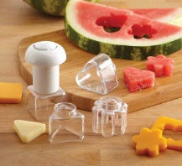Make lunchtime fun while learning about shapes. Cut cheeses, fruits, veggies and sandwich bites to add the eye appeal for fussy eaters!

Description: lceeidns[1]

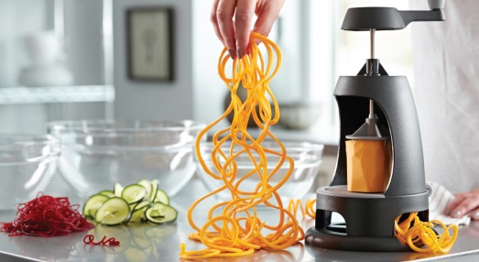 **Veggie Spiralizer** #1179 - $62.00 Eating healthy has never been easier (or more fun)! Turn fruit and veggie “noodles” into satisfying meals. Makes three kinds of “noodles” – ribbon, spaghetti, and fettuccine

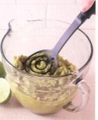**Apple Peeler/Corer/Slicer** #2430 - $34.50 Preschoolers love to help use this one, watching the peel come off and seeing the apple “slinky” that’s made. Get perfect finger food portions of apples – rings or slices - when you cut down to separate the spiral or slinky. Use with our **Mix ‘N Masher** (#2685 - $12.00) to make your own fresh applesauce or mashed potatoes. ***Also, place an apple ring on the Griddle, sprinkle with cinnamon, and then pour pancake batter over to create Apple Cinnamon Pancakes for a special breakfast!***

Please call if you’d like to learn more about The Pampered Chef® opportunity. It’s so easy to try on our apron, and flexible enough to work alongside your growing family.

*I love what I do…*

*maybe it’s right for you, too!*

**Jane Suprise** #560731

**920.574.2561**