Let’s Help Whip Cancer with these exclusive PINK Products!
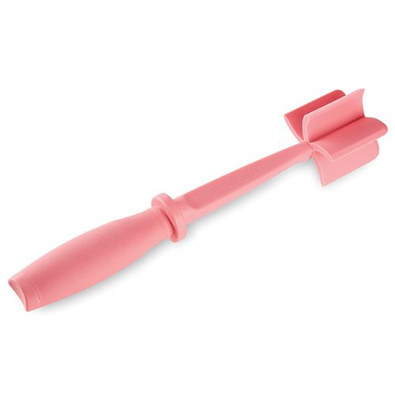 | Comparison of mini pink items  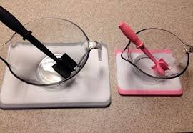  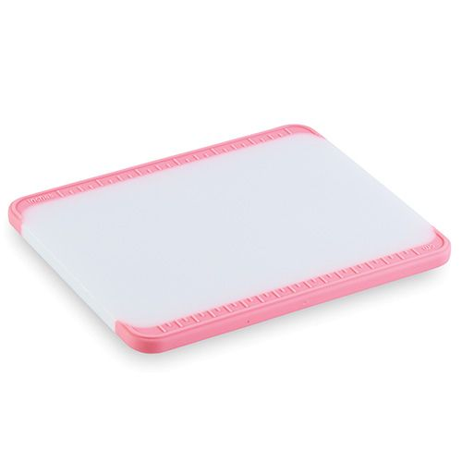
PINK Mini MixnChop  $8.50 | PINK  Bar Board  $10.50
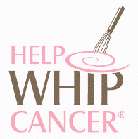
$1 from the sale of each product is contributed to the American Cancer Society’s
Breast cancer education & early detection programs.

NAME | PHONE | Pink Mini  MixnChop $8.50 | Pink Bar Board  $10.50 | SUB-TOTAL | TAX 8.10% | TOTAL | PAID BY  (CC, CHECK OR CASH)
Geneive Garcia
Phone #956-463-9485
higoobs@gmail.com
www.pamperedchef.biz/ggarcia
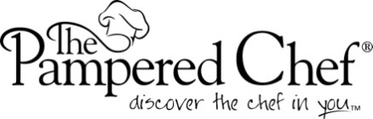
Please make checks payable to:
Geneive Garcia
(Debit or Credit Preferred)

