March Specials | April Specials | May Specials
Host | Host | Host
Earn 60% off Specialty Cutting Items when you host in March  Chop, slice, save!  Choose one at 60% off:  - Ultimate MandolineTM for $26.40 a $66 value!  - Manual Food Processor for $19.60 a $49 value!  - Food Chopper for $12.80  a $32 value!  - Simple Slicer for $12 a $30 value!  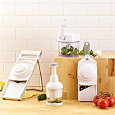  See full flyer for details and complete list of items | Earn 60% off a Top Pick Item when you host in April  Top Picks, Hot Savings!  Choose one at 60% off:  - Bamboo Knife Block Set for $174, a $435 value.  - 11” Square Grill Pan & Grill Press, for $74.80 a $187 value.  - Deep Covered Baker for $34,  an $85 value.  - Microwave Chip Maker & Simple Slicer for $22.60, a $56.50 value.  - Trifle Bowl for $16, a $40 value  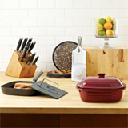  See full flyer for details and complete list of items | Earn 60% off of one Bowl Set when you host in May  Get Bowled over by Big Savings!  Choose one at 60% off:  - NEW Silicone Prep Bowl Set for $7.80 a $19.50 value.  - Stainless Steel Mixing Bowl Set $33.80, a $84.50 value.  - Batter Bowl Set with Exclusive Pink Lids $11.40, an $28.50 value. ($1 contribution made to American Cancer Society for every set purchased)  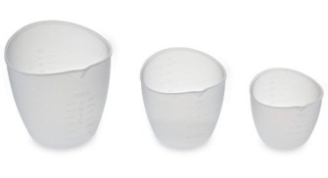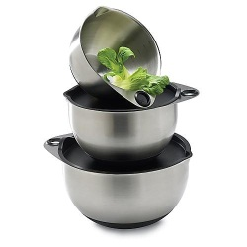  See full flyer for details and complete list of items
Guests | Guests | Guests
Choose a FREE Bar Board or the Small Flexible Cutting Mats with a purchase of $60 or more!  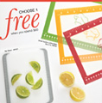 | Receive a FREE Egg Slicer Plus with a $60 purchase –  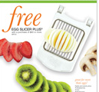 | Receive TWO 1-Cup Prep Bowls FREE with a $60 purchase  And Paint the town pink with Help Whip Cancer items!  Pink Mini Scoop & Measure $5.50  Pink & White Twixit Clip Combo Pack $6.00  Pink Color Coated Paring Knife $13.50  Dots Microfiber Towel $8.50  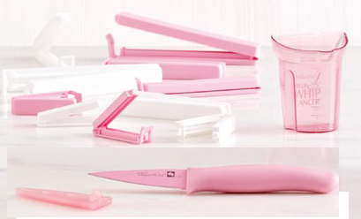
Host a show and you can earn your own Shopping Spree!!  Talk to me about picking your date. | Laura Harlow  410-804-9663  ivykeep@gmail.com  www.pamperedchef.biz/ivykeep  www.facebook.com/ivykeepPC | 

